
ADMH WITS
Payment Vouchers Reconciliation Guide
Version 1.0

Prepared by FEI Systems

Date 10/20/2026

Table of Contents
Record of Changes 1
1. Introduction 2
1.1. Purpose 2
2. Payment Vouchers Reconciliation 2
2.1. Individual Claim Reconciliation 2
2.2. Encounter List 2
2.3. EOB Transactions 4
2.4. Payment List 4
2.5. Reports 7
2.6. SSRS 7
2.6.1. Checkwrite Report 8
2.7. Tracing Individual Claims 8
2.8. Reconciling Medicaid H835 included in Specific Payment Vouchers 10
2.8.1. Claim Number Submitted to Medicaid 11
3. Checkwrite (payment voucher) process illustration 12
4. FAQ 12

List of Tables
Table 1: Record of Changes 1

List of Figures
No table of figures entries found.

Record of Changes
Table 1: Record of Changes
Version Number | Date | Author/Owner | Description of Change
1.0 | 10/20/2026 | FEI | Establish reconciliation guide

Introduction

Purpose
The purpose of this Payment Voucher Reconciliation Guide is to provide WITS users with the information and tools necessary to reconcile Medicaid and government-funded payments, trace individual claims through the billing lifecycle, and validate payment voucher activity. This guide outlines the key WITS screens, reports, and reconciliation processes available to support the review of encounters, claim items, billing transactions, EOB transactions, payments, and checkwrites. It also provides practical examples and reporting guidance to help providers research payment activity, identify claim outcomes, and efficiently reconcile payment voucher data with information maintained in WITS.

Payment Vouchers Reconciliation

Individual Claim Reconciliation
In WITS, billing records for billed treatment services trace back to the Encounter number – sometimes labeled Delivered Service id. Generally, if you have the option to search by the Encounter number, you will see the full billing history for that billed service. When an Encounter is released, it creates a record in the Claim Item table. When Claim Items are batched, a Claim is created in WITS. The Claim id is transmitted to Medicaid with WITS prefacing the number; the number in WITS is displayed at the bottom of the Claim Item profile.
There are several screens in WITS that can be utilized to assist in claim reconciliation. These are grouped in the Agency -> Billing menu item. The screens referenced and discussed in this document are Encounter List, Claim Item List, Billing Transaction List, EOB Transaction List, and Payment List.

Encounter List
The Encounter List can be used to see the billing history for individual Encounters. There are many search options available on this list screen. The staff member can search by Encounters in a range using the colon, or search for Encounters with no balance or a balance more than 0 using the > symbol. When an Encounter is found the menu to the right includes the option “Billing History.”

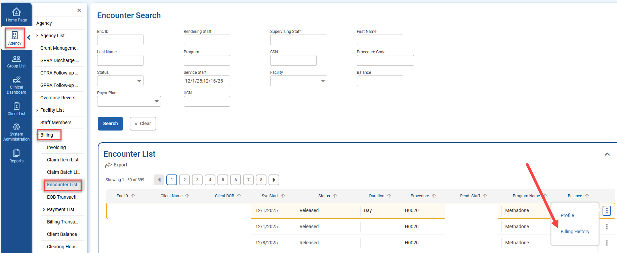
Billing History shows records from the Encounter, EOB Transaction tables for this individual Encounter.

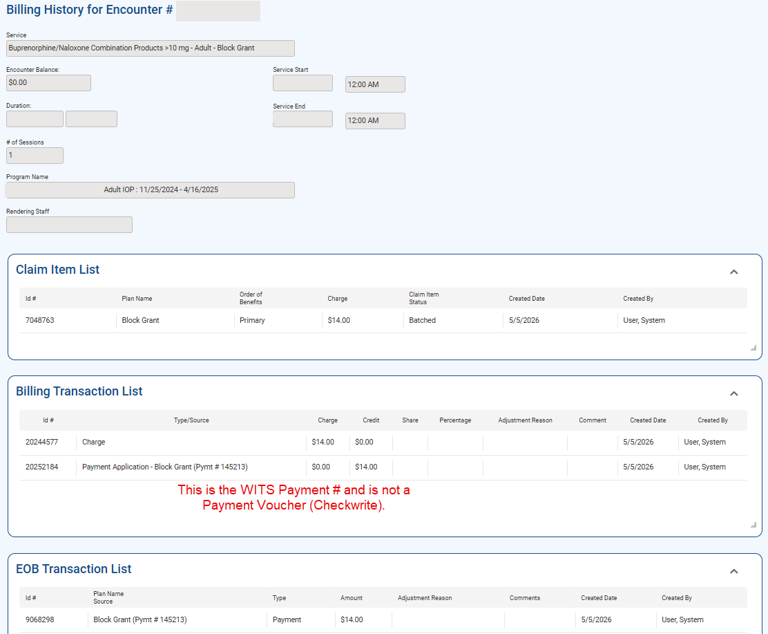

EOB Transactions
The EOB Transaction list loads from the ‘Show Payment Application’ button of the Payment Profile, but it can also be accessed directly from the Agency -> Billing -> EOB Transaction menu item. This screen has a search at the top with many options to review Encounters/Claim Items. The date fields can be used to search ranges using the greater or less than symbols. This screen also had an Export option to review the list of Claim Items in Excel.
Date Filtering Examples:
Range: 1/1/2026:2/1/2026
Greater than: >1/1/2026
Less than: <1/1/2026

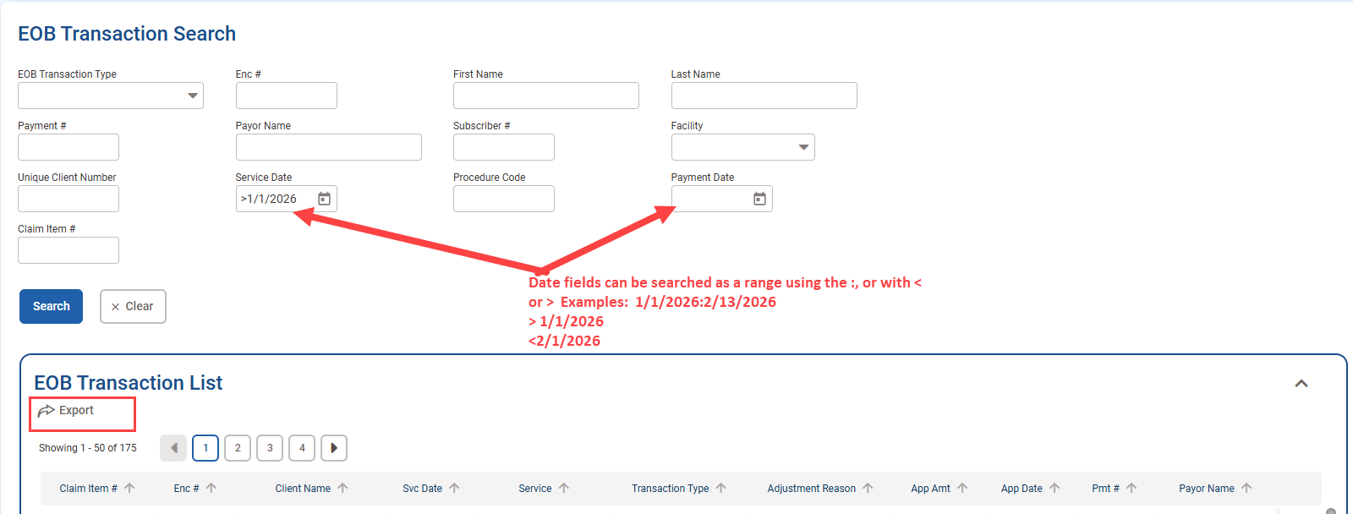

Payment List
The payment list is a universal list of payments the agency has received. It’s available in the Agency -> Billing – Payment list menu item. Please note this is WITS Payments and not a Payment Voucher or Checkwrite.

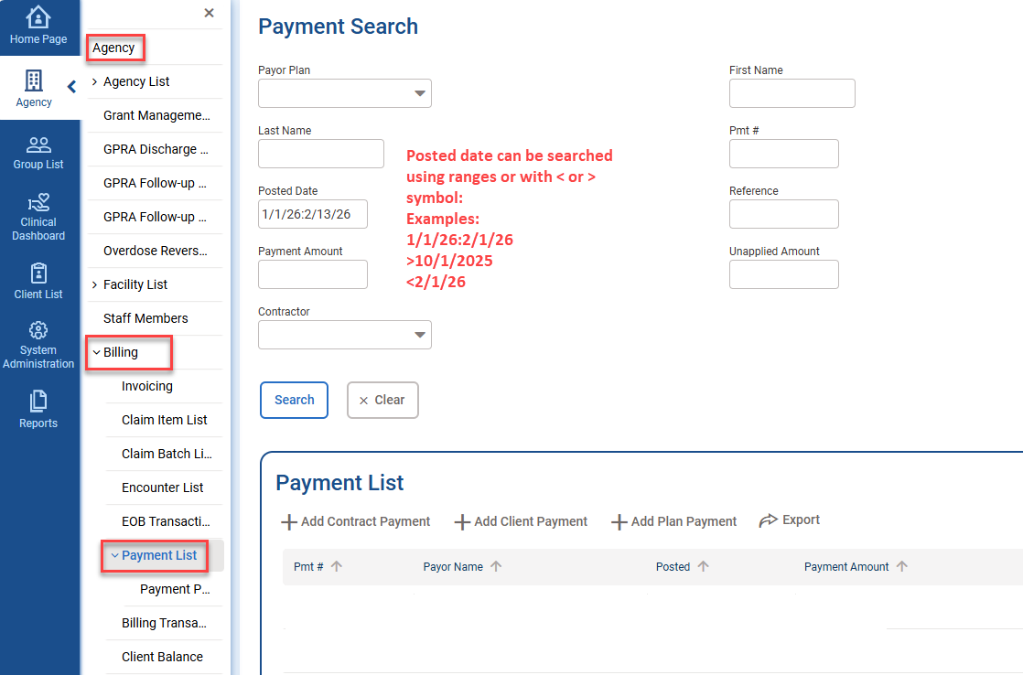
The list of Payments can be exported using the button at the top of the list. The details of related claims can be found by reviewing an individual Payment and clicking ‘Profile’:
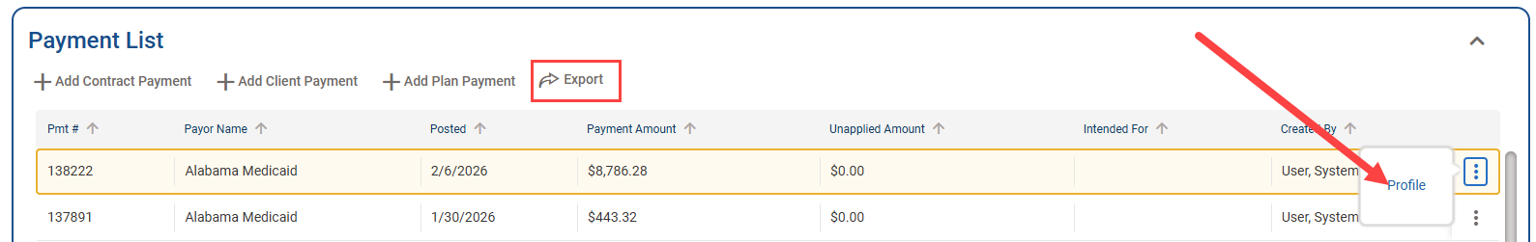
The Payment Profile shows other pertinent information regarding the payment. At the bottom is the “Show Payment Application” button that can be used to see the billed services to which this payment applied, this button opens the EOB Transaction list.
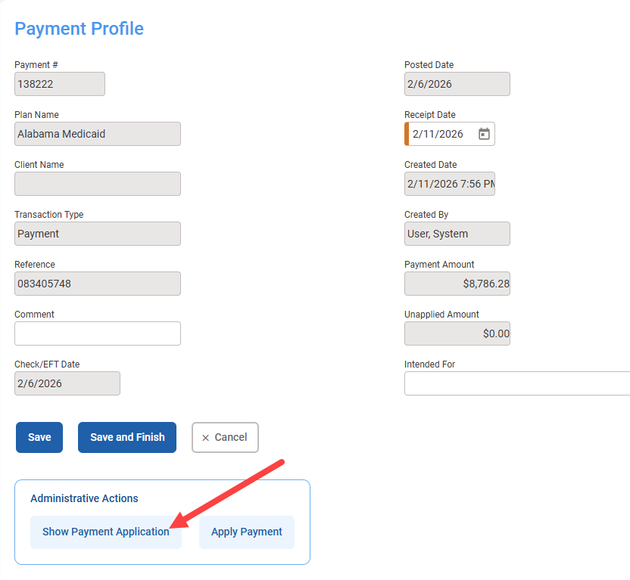
The EOB Transaction list opens for the specific payment and has an export button to show all paid billed services.
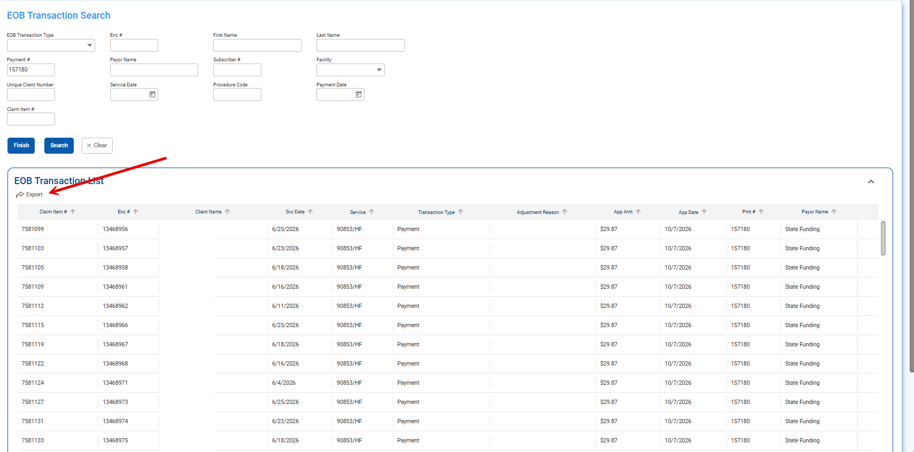

Reports
There are Billing reports available in WITS. The following menu item requires a role: Reports Access. More information about these reports is available in the ADMH WITS Billing document.
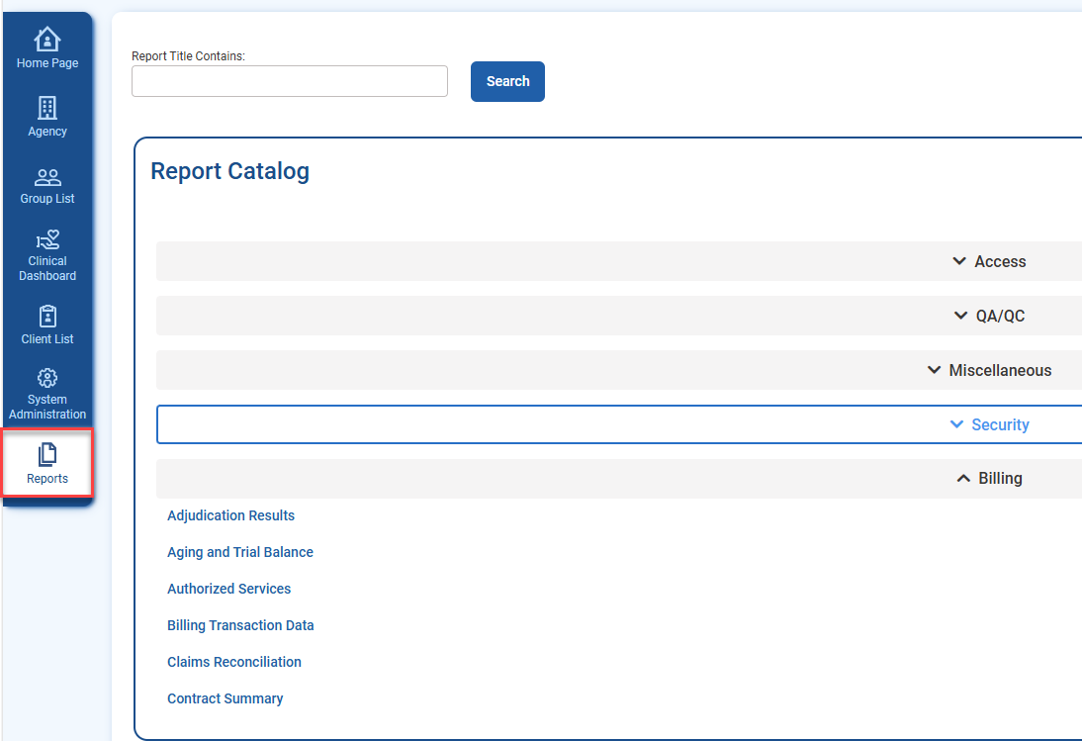

SSRS
SSRS is the ad-hoc report writing tool available in WITS. It allows the staff to create their own reports from data in WITS. A role is required to access (SSRS Agency Reader), and permissions for SSRS have two levels, the first level is read-only, and the second permission allows the staff member to create and/or edit reports. When the staff member has an SSRS role, the link to SSRS is at the top of the screen. If you are unable to see the SSRS Reports link, please contact DMH.WITS@mh.alabama.gov for assistance​.

Checkwrite Report
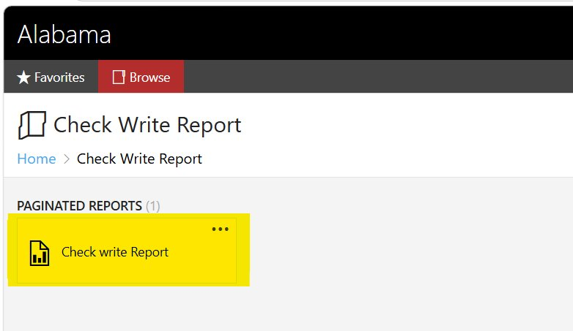
Run the report for individual Checkwrite and export the results to Excel.
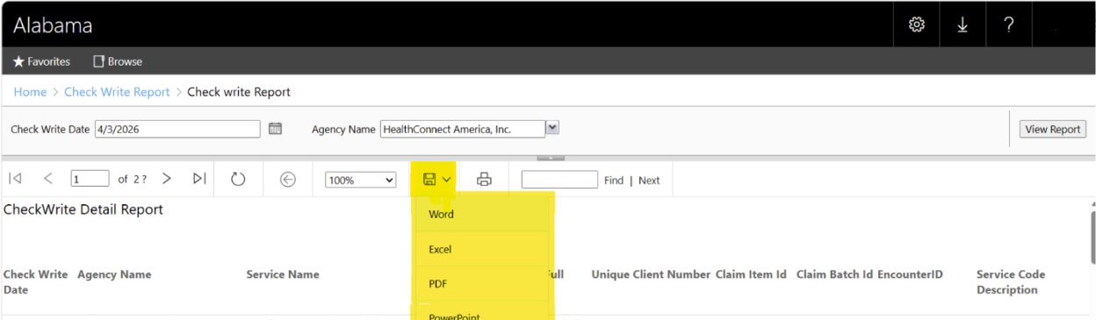

Tracing Individual Claims
For tracing billing history for an individual billed service please see the following examples. This utilizes:
- An export provider by ADMH of the Payment Voucher record
- The Agency -> Billing -> EOB transaction screen
  - The Agency -> Billing -> Billing Transaction screen
- Output from the Payment Voucher SSRS report.
Example 1: Encounter # (delivered_service_id) 12983613
WITS EOB screen for 12983613: total payment was $25
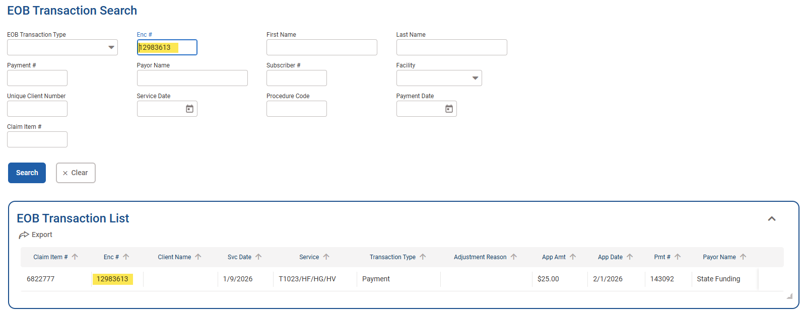

Complete Payment Voucher History for 12983613:

Example 2: Encounter # (delivered_service_id): 12799580 : Voided(Reversed) Claim
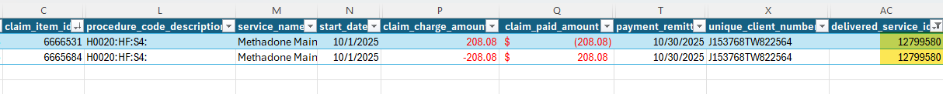
WITS EOB transaction for 12799580 : Total payment overall was 0:
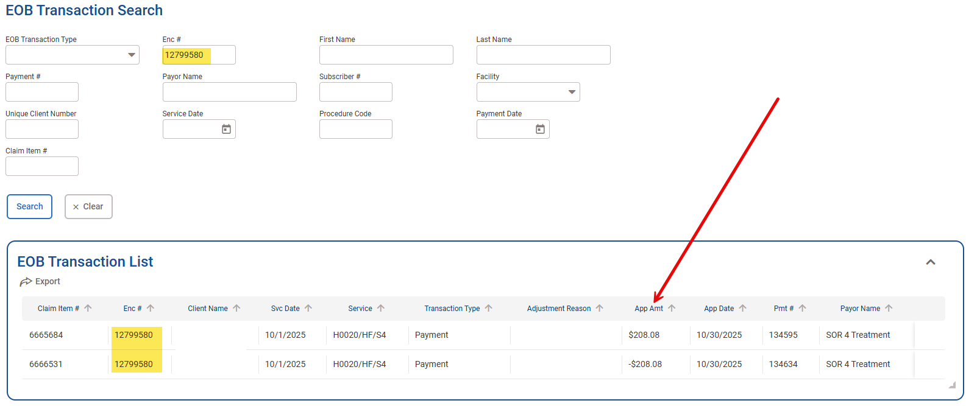
Complete Payment Voucher records for 12799580 – matches net 0 payment:
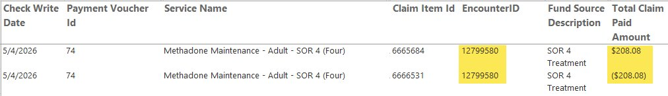

Reconciling Medicaid H835 included in Specific Payment Vouchers
For assistance reconciling data exported from WITS to STAARS as a payment voucher, providers should be encouraged to utilize SSRS. Additionally, the following information may be useful.
Any screen that has a date field can accept a range. WITS Payments and the EOB Transaction screen would probably assist the providers the most in this scenario.
Every H835 that is received from Medicaid creates a unique WITS Payment based on the date in the H835 file. Please note a WITS Payment is different from a Payment Voucher (Checkwrite). Searching the Billing -> Payment list screen can allow the providers to see the distinct Medicaid payments that have been received into WITS. The Payment Voucher sent to STAARS, uses the Posted Date field to pull the data. When searching in WITS, posed date could be used to search the time from the last Payment Voucher Checkwrite date to the current Payment Voucher Checkwrite date. Reviewing the applicable payments in that date range, which should be easily traceable to individual Medicaid H835s, the providers can then select “Payment Application” and see/export all claims for that payment.
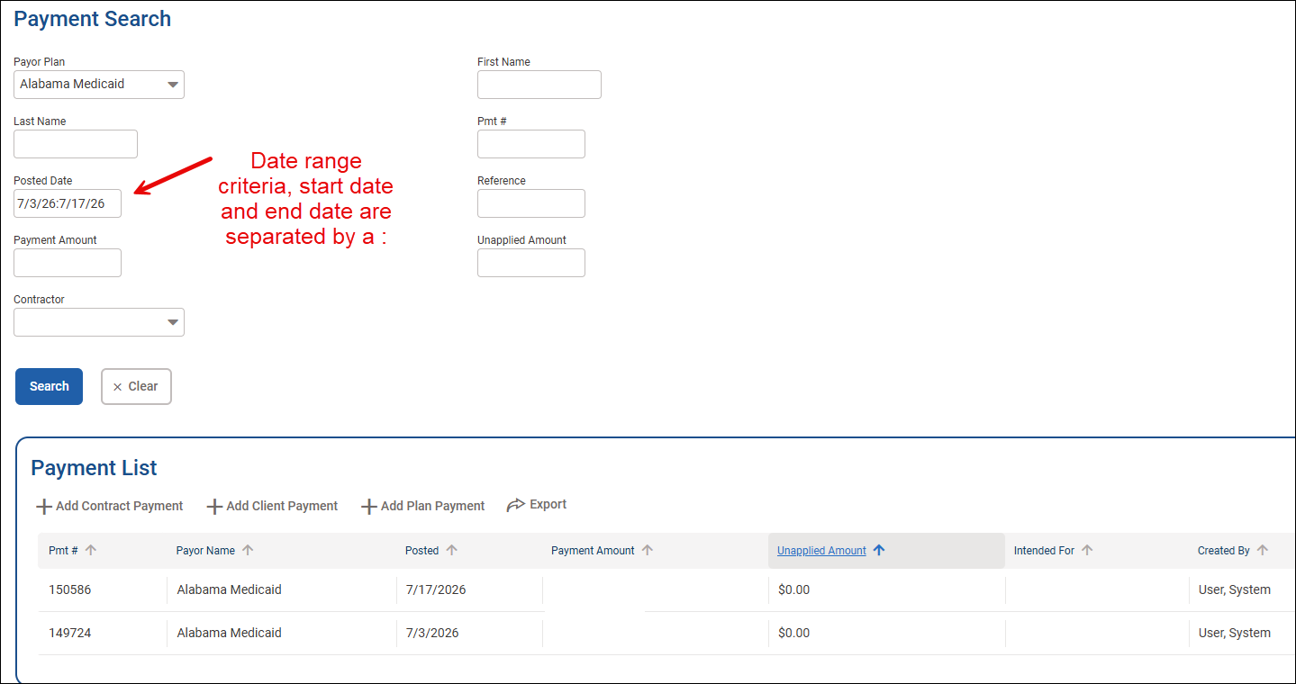
Additionally, the EOB Transaction screen could be used in a similar manner. Utilizing this screen allows easier access to view/export all the applicable individual claims.
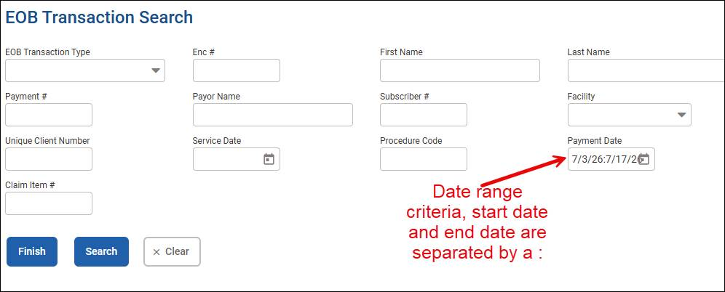

Claim Number Submitted to Medicaid
Please note: any claim sent to Medicaid is assigned a WITS claim number. This can be found by navigating to Agency -> Billing -> Claim Item List and reviewing the profile of the Individual Claim Item. The following is displayed at the bottom of the Claim item:
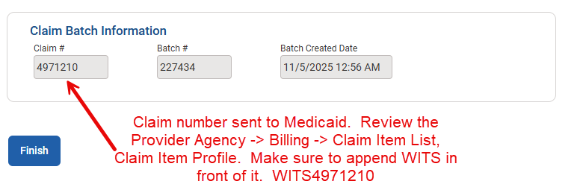

Checkwrite (payment voucher) process illustration
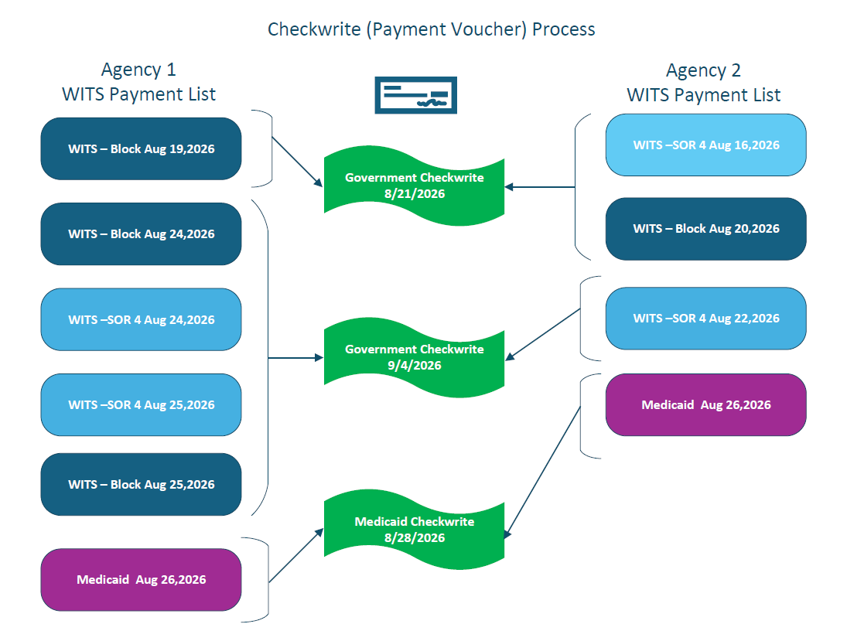

FAQ
- We had a claim that was denied, how can we see more information in WITS?
  - Review the Agency -> Billing -> Encounter list, search for the Encounter and select “Billing History.”
OR
  - Review the Agency -> Billing -> EOB Transaction list, search for the Encounter
OR
  - Reach out to ADMH IT for any other questions.

- We need to replace a submitted claim via H837, how do we do this?​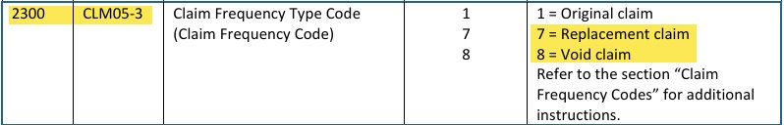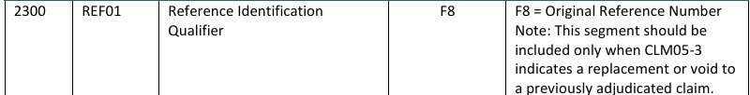

For more information please see the ADMH website.​
- How do I trace a claim through WITS?
Inside WITS, claims take slightly different paths whether being billed to Government Contract funds or Medicaid funds:

Government Contract Claims – processors generally run hourly generating Claim Batches and accepting provider claim submissions and adjudicating. Please Note when EOB is updated a WITS payment is generated.
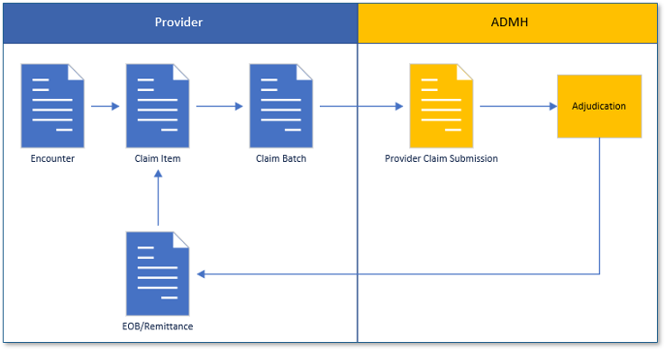

Medicaid claims – processors to generate the Claim batch, the Clearing House batch and generate the H837 and transmit it generally run hourly.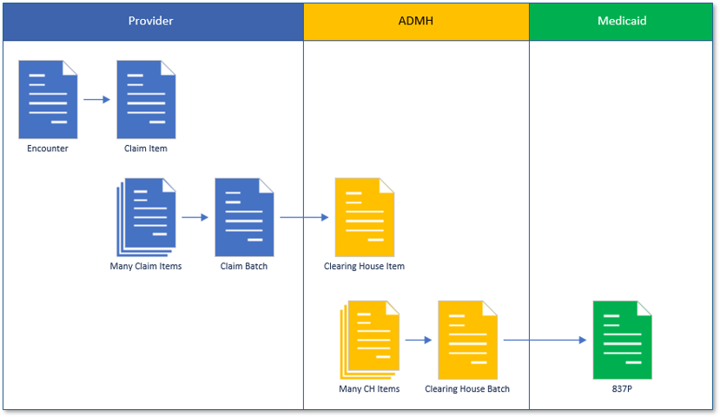
WITS Payments:
Government billing generates payments usually within a few hours of the Claim creation.

Medicaid generates H835 files on a published schedule every few weeks. The H835 files are automatically loaded into WITS when available.

Both payments are visible on the WITS Payments screen.

Checkwrite (Payment Voucher)
ADMH generates Checkwrites on a published schedule.
Checkwrites are either government funding or Medicaid. When a Checkwrite is created, WITS is to pull all paid claims of the funding type since the last Checkwrite of the same type.

To see all related activity for a Checkwrite you can utilize the WITS Payment screen (search the Posted Date field with a range) or the EOB Transaction (Payment Date field – use a date range).

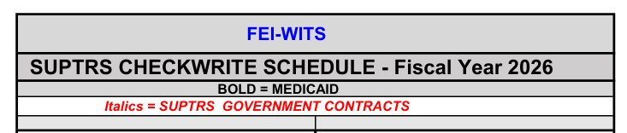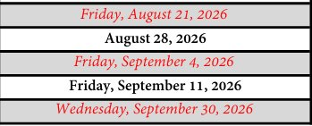

If confirming the 9/30/26 Government Checkwrite, use the EOB Transaction screen and put the date range of the day after the last Checkwrite through the current Checkwrite date:

Option 1: EOB Transaction:
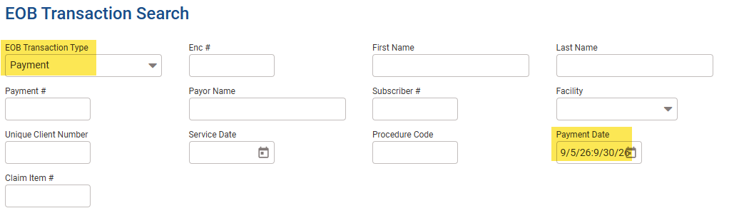
Review export and remove Medicaid if reviewing the Government funding claims or remove Government funded claims if reviewing a Medicaid Checkwrite.

Option 2: Payment screen:
